Genetics

Assessment Statements
- Explain the technical terms dominant, recessive, intermediate as well as phenotype and genotype.
- State Gregor Mendel’s contribution to biology.
- Identify the possible genotypes and phenotypes of a crossbreed with the help of a combination square.

Technical terms
An allele is the variant of a gene: the gene for eye color is present in all people, but the alleles (blue, brown, green, ...) can be different.
If the information of an allele is always visible, the allele is dominant. If the allele is weaker compared to other alleles, it is recessive: the information is only visible if no dominant alleles are present.
If two parents have blue and brown eyes and their child has brown eyes, then the allele for the brown eye color is dominant and the allele for blue is recessive. We write dominant alleles in capital letters and recessive alleles in lower case letters. In our example, this would be B for brown and b for blue.
Whether an allele is dominant or recessive depends on the type of proteins for which the alleles code. In the example of eye color, the brown allele codes for a protein that produces dark pigment and masks the blue background of the eye. The allele for blue eye color does not code for a protein, so the dark pigment is missing.
We refer to the information on the genes as the genotype and what is visible as the phenotype. Humans (and animals and plants) are diploid, so the genotype always consists of two alleles. In the example of eye color, possible genotypes are BB, Bb and bb. Phenotypes would be brown eyes and blue eyes.
We can only find out whether an allele is dominant or recessive by carefully observing many living organisms. Pedigree analysis is a useful tool for this.

Combination square
With a little practice, you quickly get "the genetic view" and can see the genotypes of the descendants directly from the ancestors. However, this is also prone to errors. The combination square is a useful tool for finding all possible descendants of the cross between two genotypes. It is always filled out in the same way, so you will never overlook a variant.
Bb x bb

gametes
gametes

Mendel’s observation
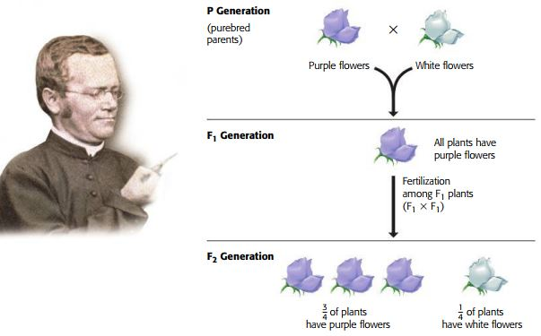

Describe the phenotypes and genotypes of the P generation (Parental = parent generation). Take the letter P for the alleles (the letter can be chosen freely, but it makes sense to take something that has to do with the phenotype).
Phenotype: PL and Pw
Genotype: PLL and Pww
Do the same with the F₁ generation (Filial = daughter generation 1)
Phenotype: F₁L
Genotype: F₁Lw and F₁wL
Now fill in the combination square. Cross two plants from the F₁ generation to find the genotypes and phenotypes of the F₂ generation.

 |  | gametes
 |  | L | w
gametes | L | LL | Lw
 | w | Lw | ww

Intermediate inheritance
In a meadow you find red, yellow and orange flowers of the same species.
Determine the phenotypes and genotypes of the three variants:
Phenotype | R | Y | O
Genotype | RR | yy | yR, Ry

Cross a red flower with a yellow flower using the combination square:

 |  | gametes (R)
 |  | R | R
gametes (Y) | y | Ry (O) | Ry (O)
 | y | Ry (O) | Ry (O)
re

Task for the quick and courageous ones
This task is easy to solve - if you don't get confused by all the information. Proceed as you have learned in the simpler examples. And always consider whether what you are doing can actually work in the cells. Good luck!
So far, we have only looked at individual genes. However, it is possible to analyze two genes that are inherited independently of each other in one step. Again, the combination square serves as an aid.
In Gregor Mendel's peas, there is a gene (Yellow) for the color (Y=yellow, y=green) and a gene R (Rough) for the surface structure (R=smooth, r= wrinkled).
Cross a plant with only dominant alleles with one that has only recessive alleles.

Now cross two plants of this generation with each other.

Used Tools and References
deepL: back translation of own texts
- Reece, J. B. et al. (2018). Campbell Biology. (11th edition). Pearson Education.
- Simon, E. J., Reece, J. B., Dickey, J. L. (2013). Essential Biology with Physiology. (4th edition). Pearson Education.

CC BY 4.0 DEED for contents created by Daniel Margadant
For other sources (e.g., figures) please consider © of corresponding reference

